C++ ASIGNMENT

Name: Adedapo Abiodun Joseph

Form No: F2308805

1. C++ Program to determine if a point is below a rectangle: *codes:*

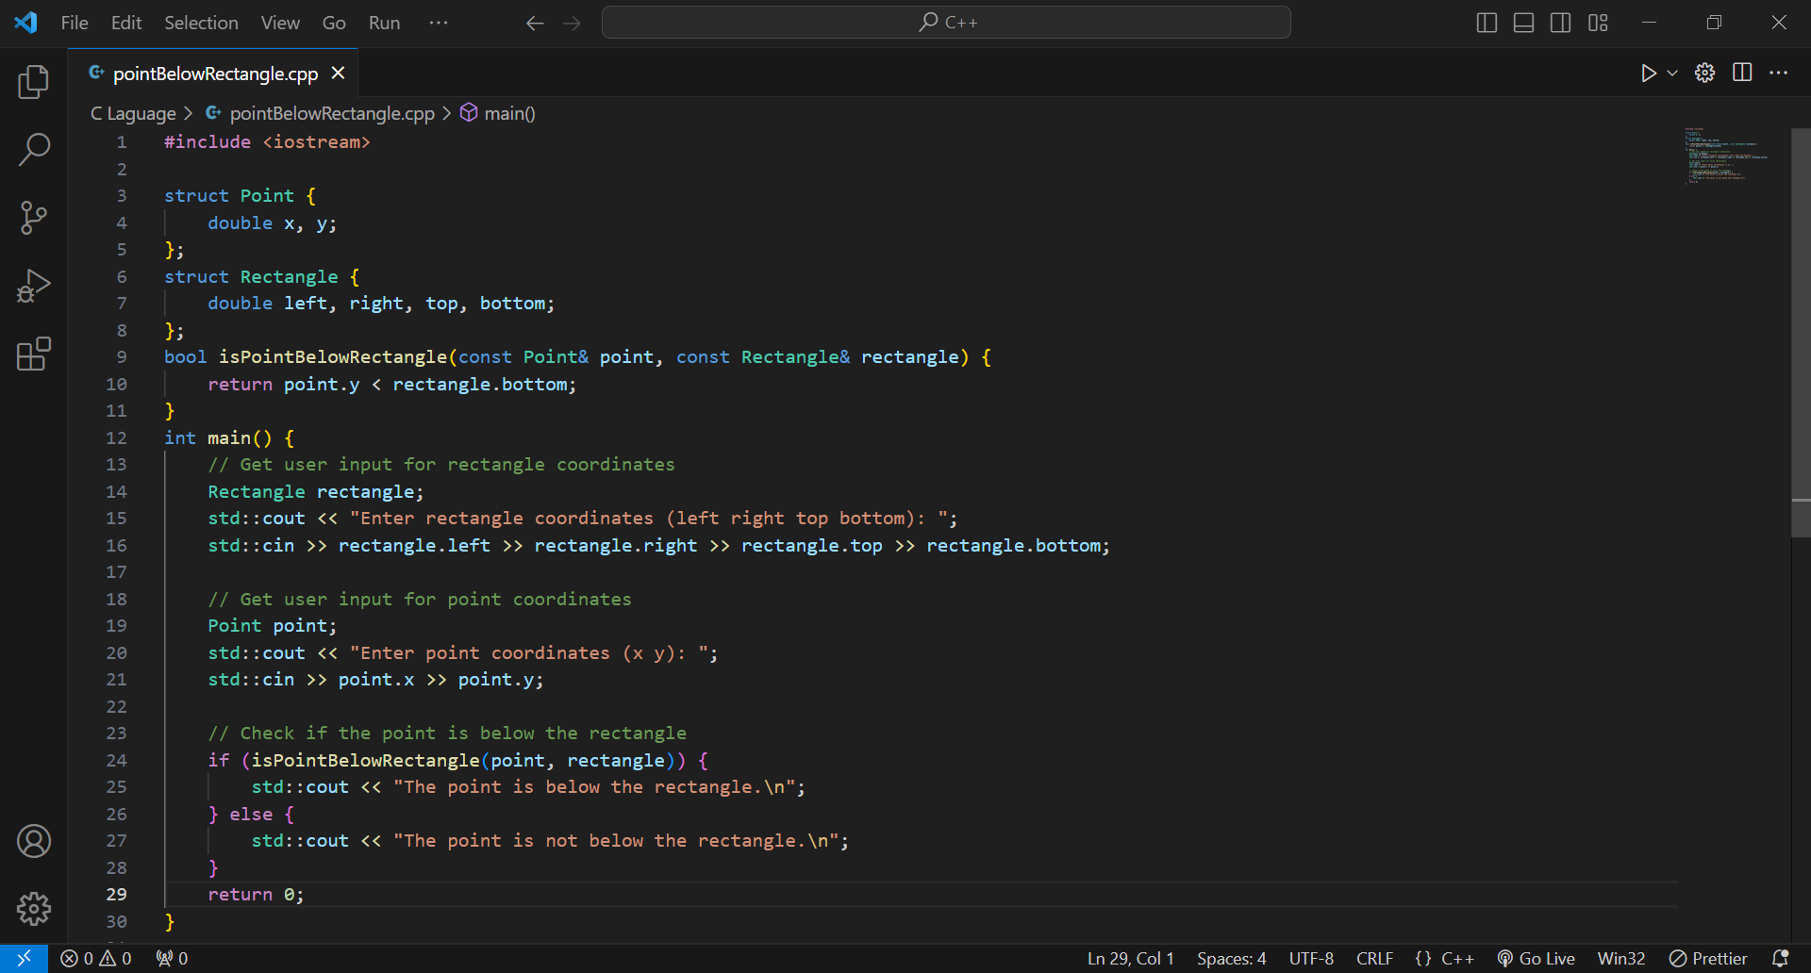

*Output*

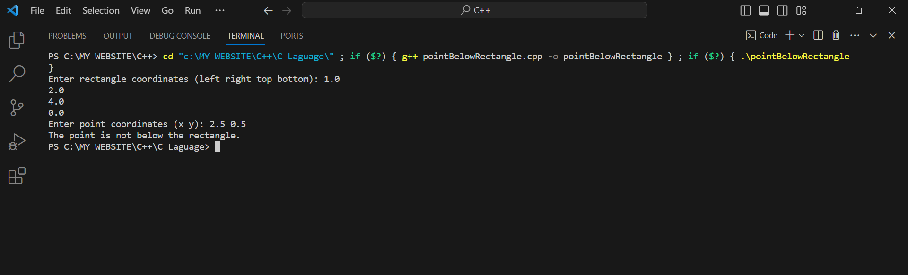

1. Odd number beteen 1 and 1000: *Code*

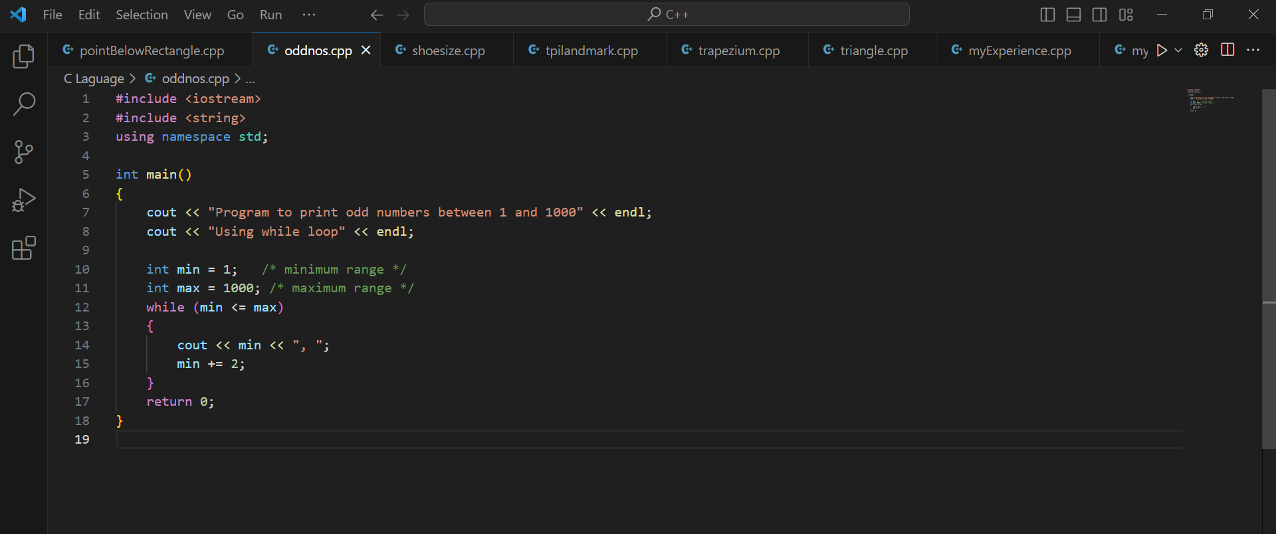

*Output*

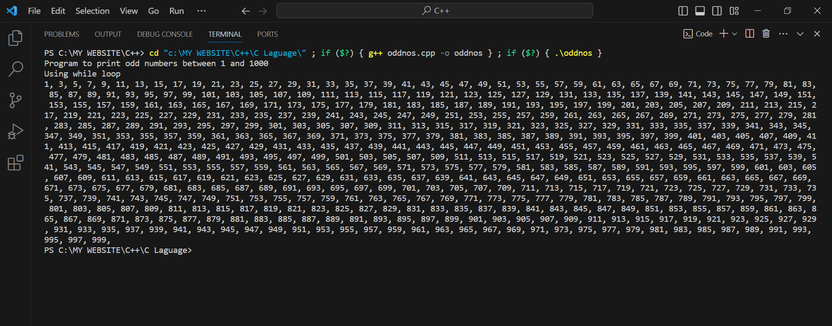

1. C++ program to calculate shoe size: *Codes & Output*

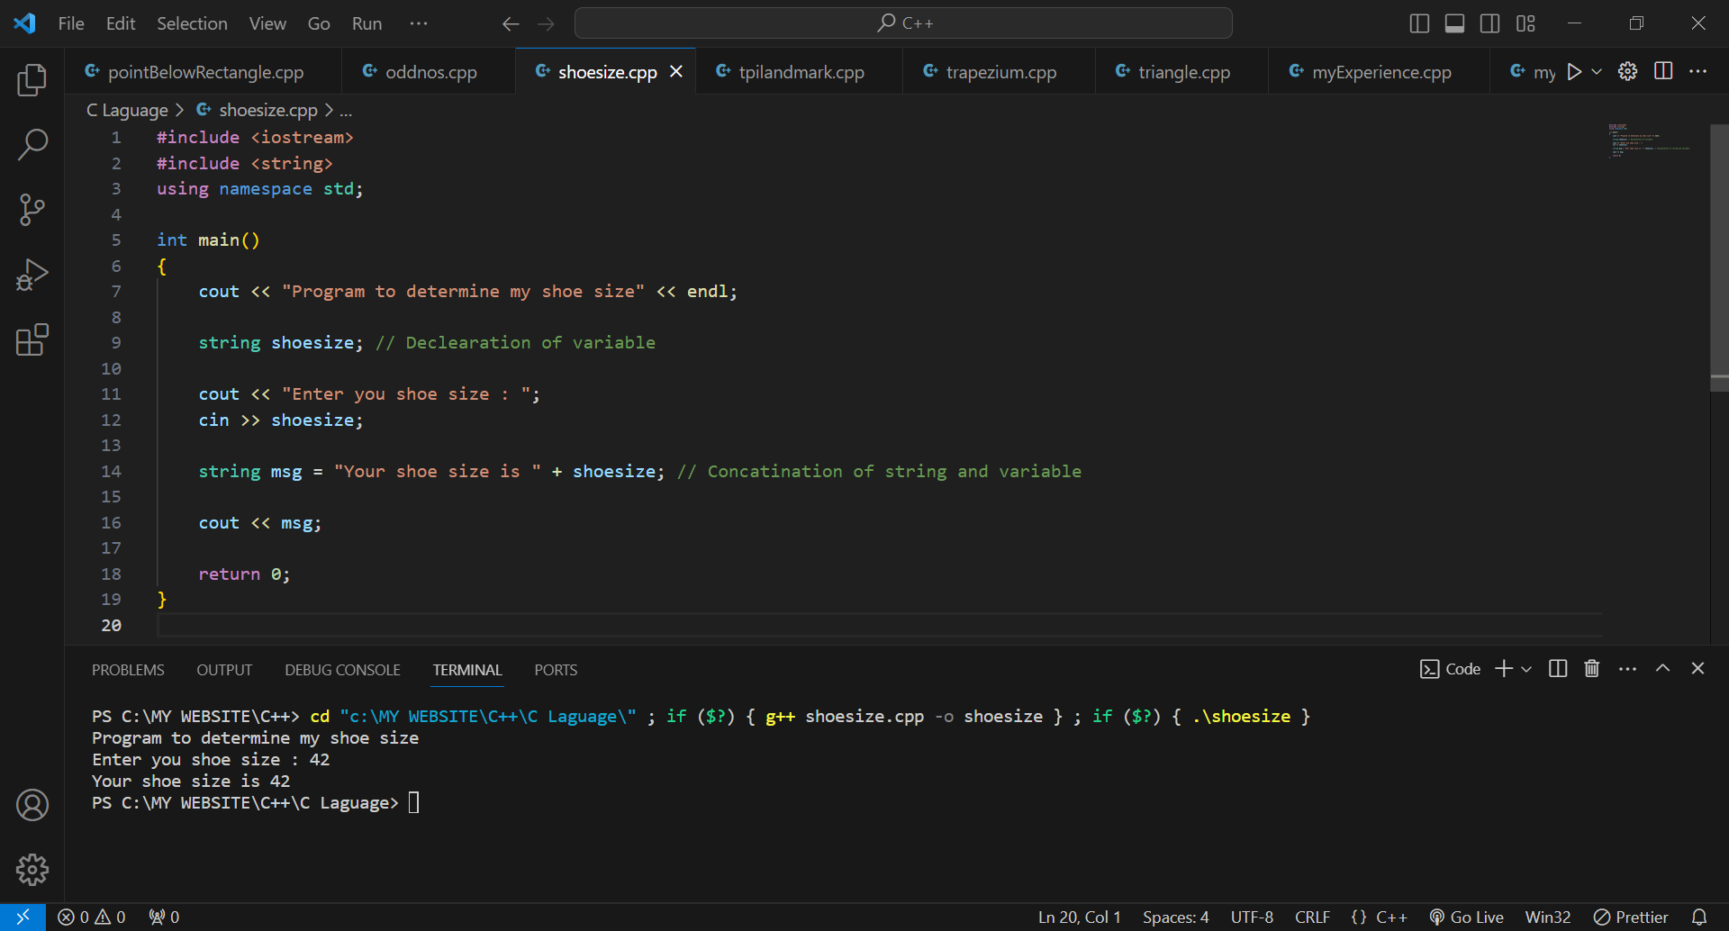

1. A program to calculate the area/circumference of The Polytechnic, Ibadan: *Code*

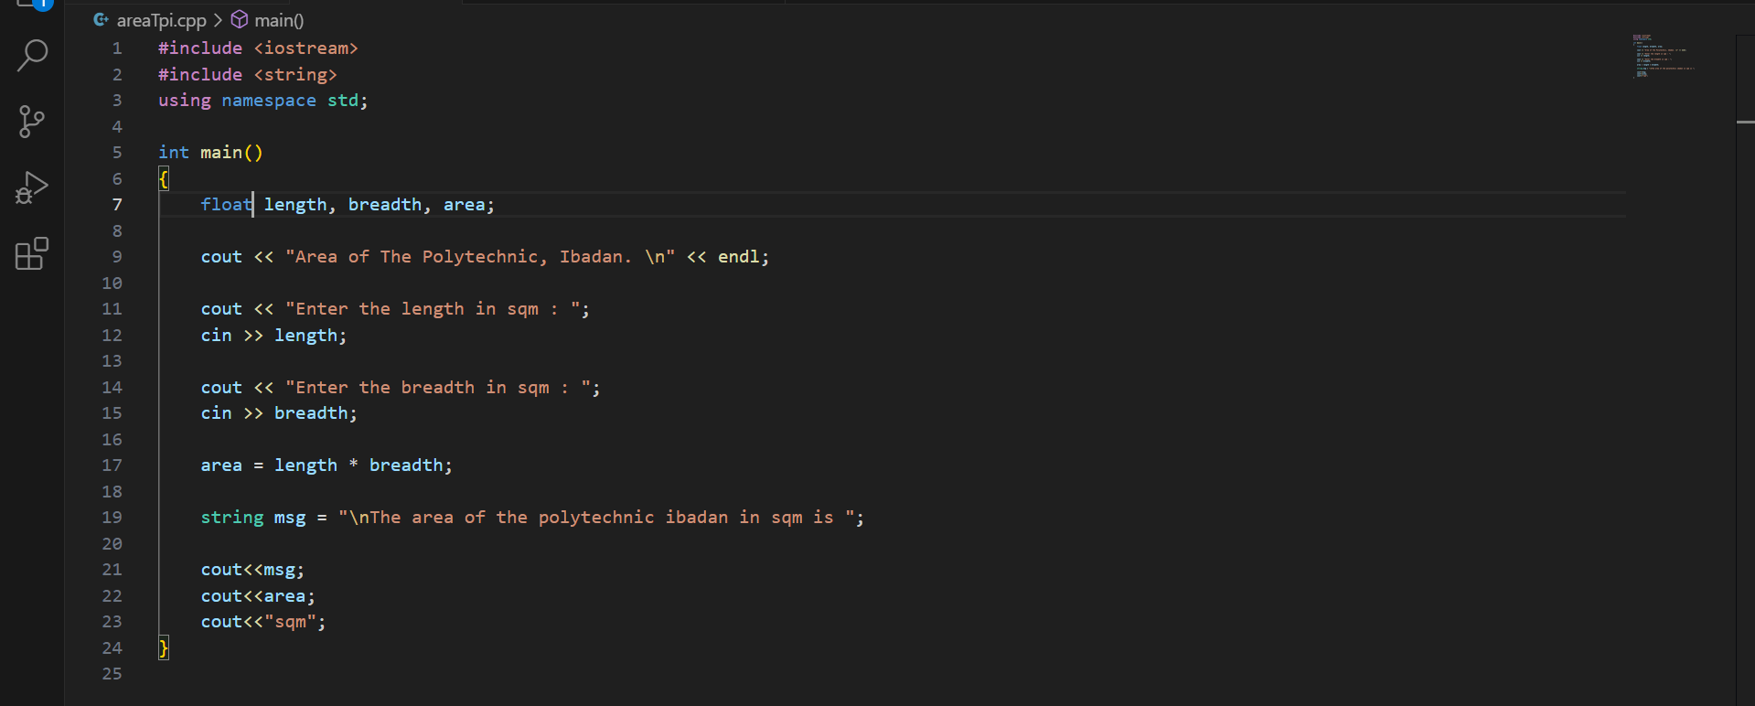

*Output*

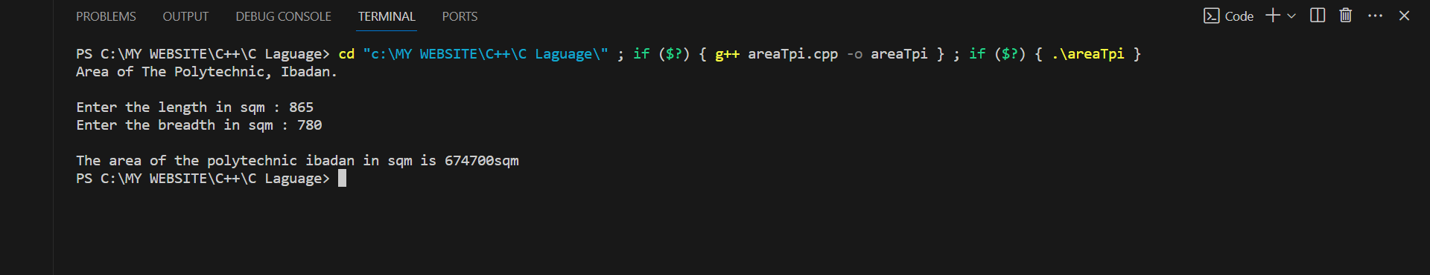

1. Write a C++ program to generate a triangle: *Code*

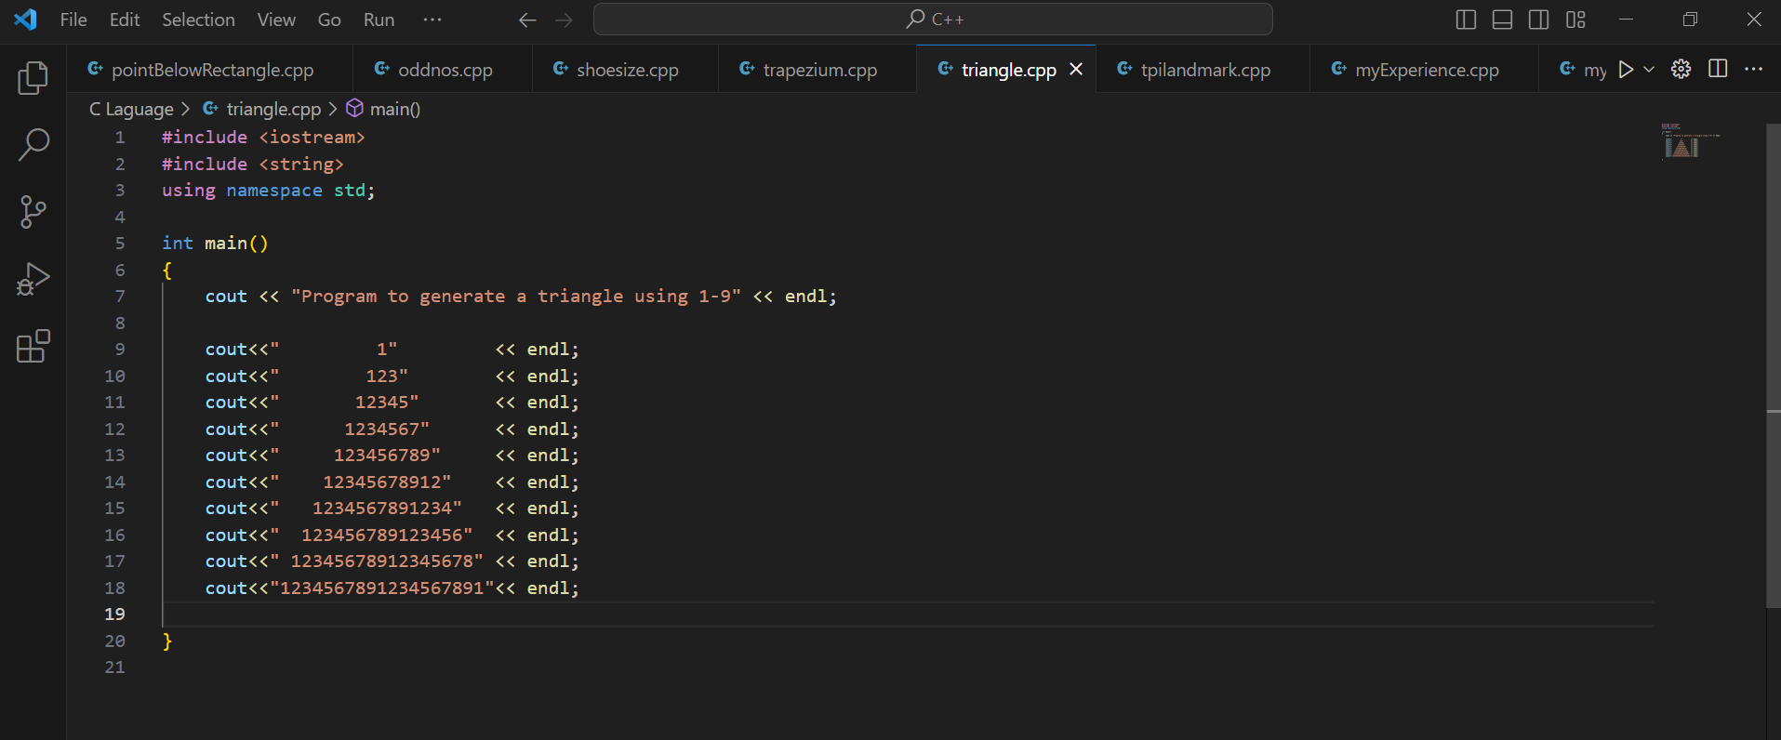

Output:

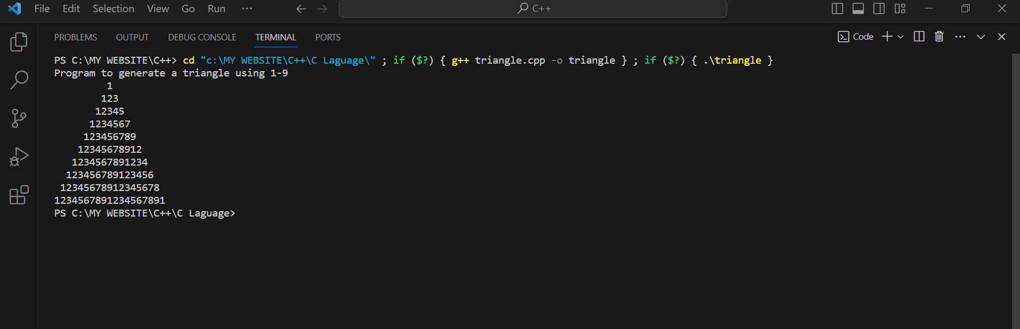

1. My C++ programming experience to my friend in another higher institution: C*ode*

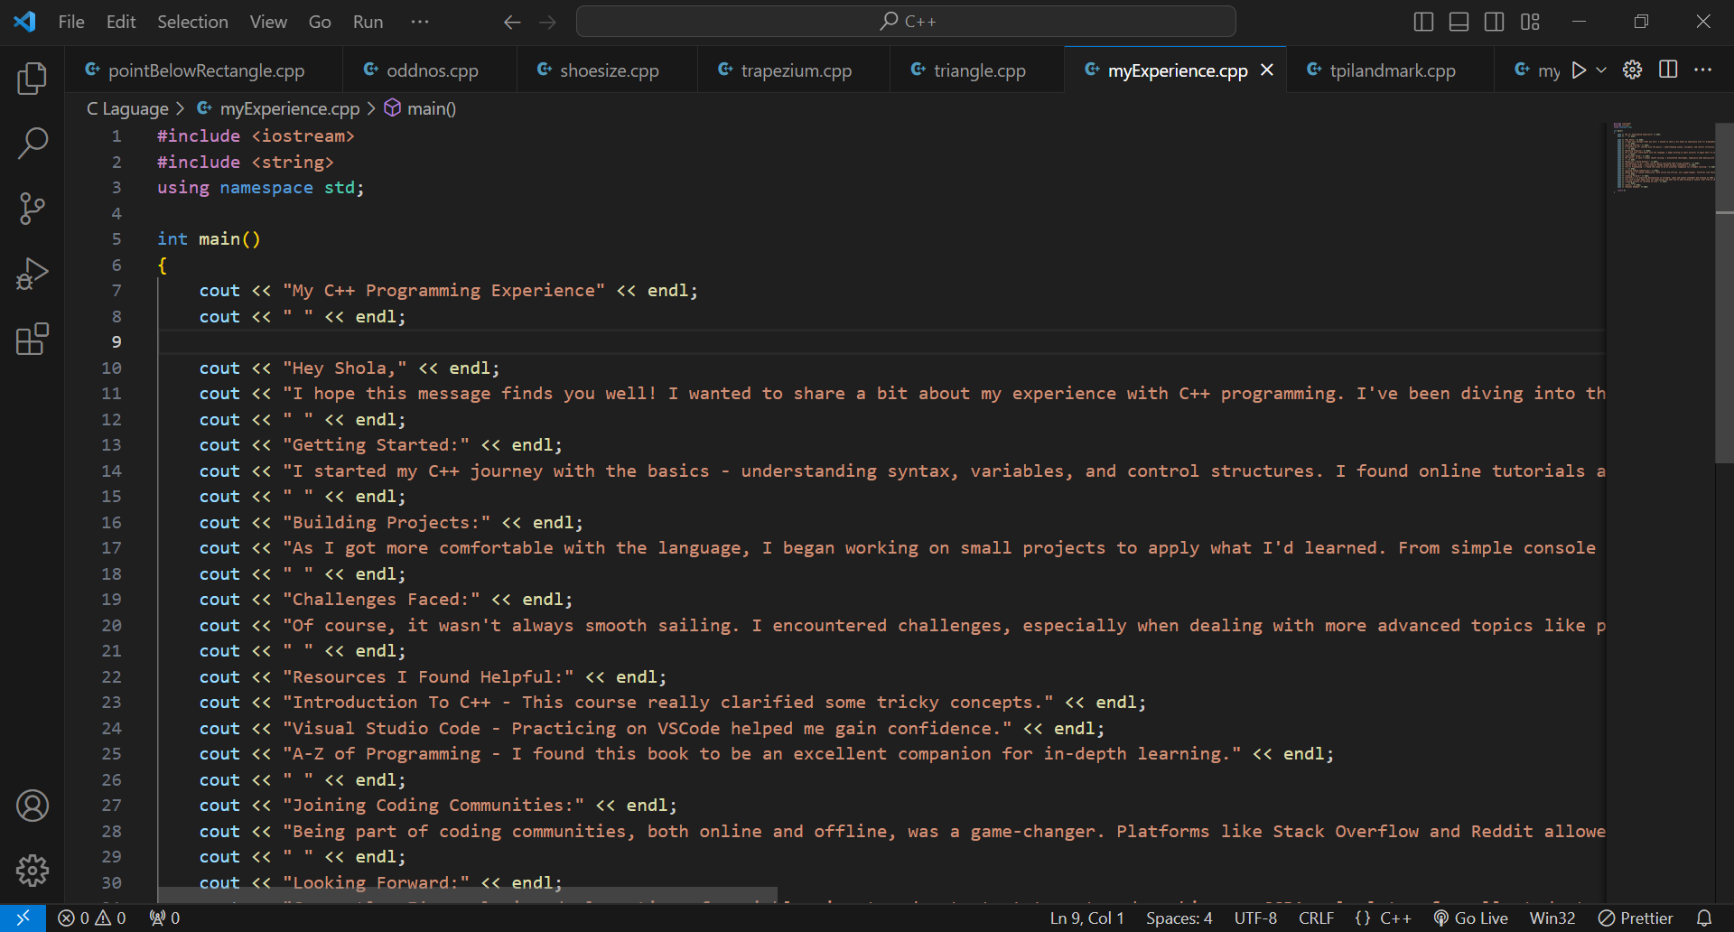

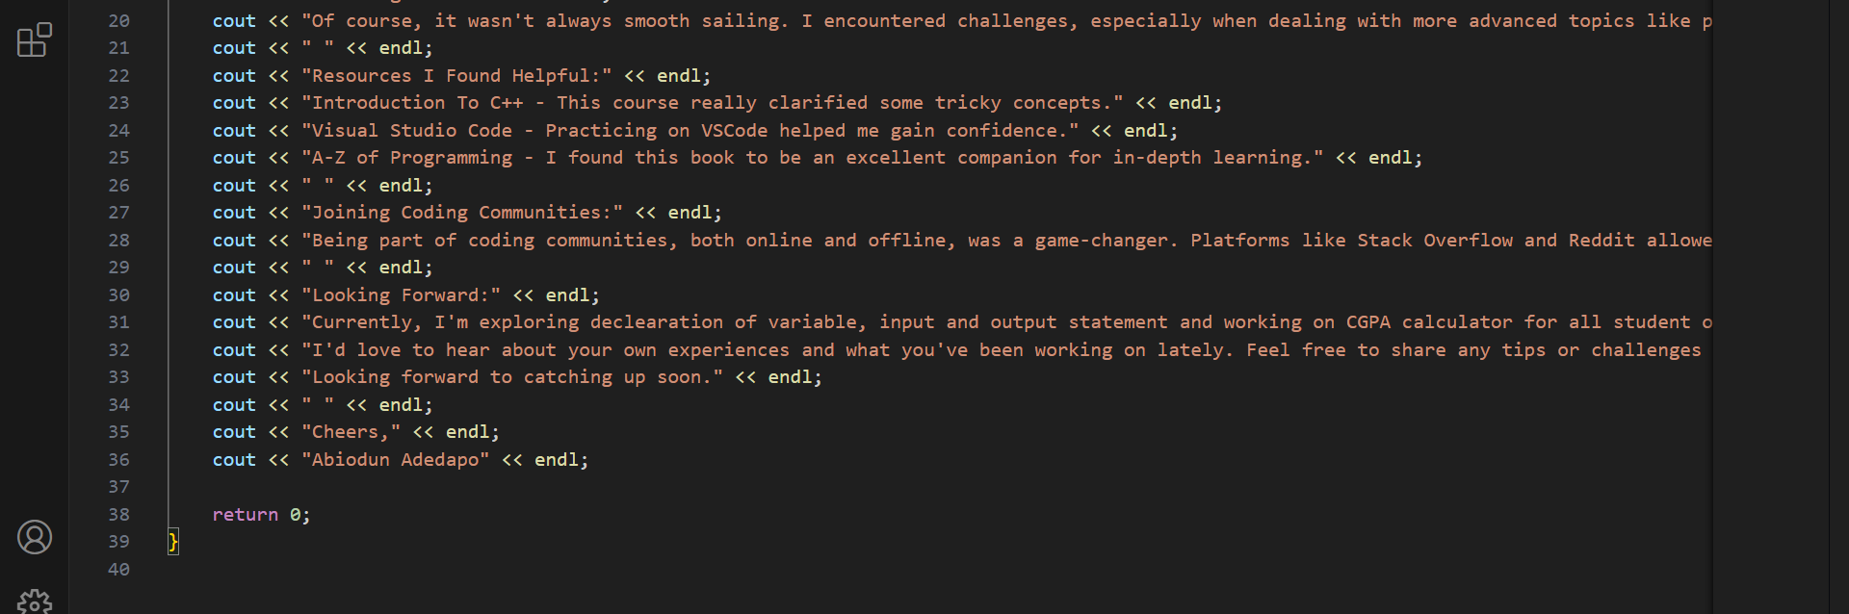

*Output:*

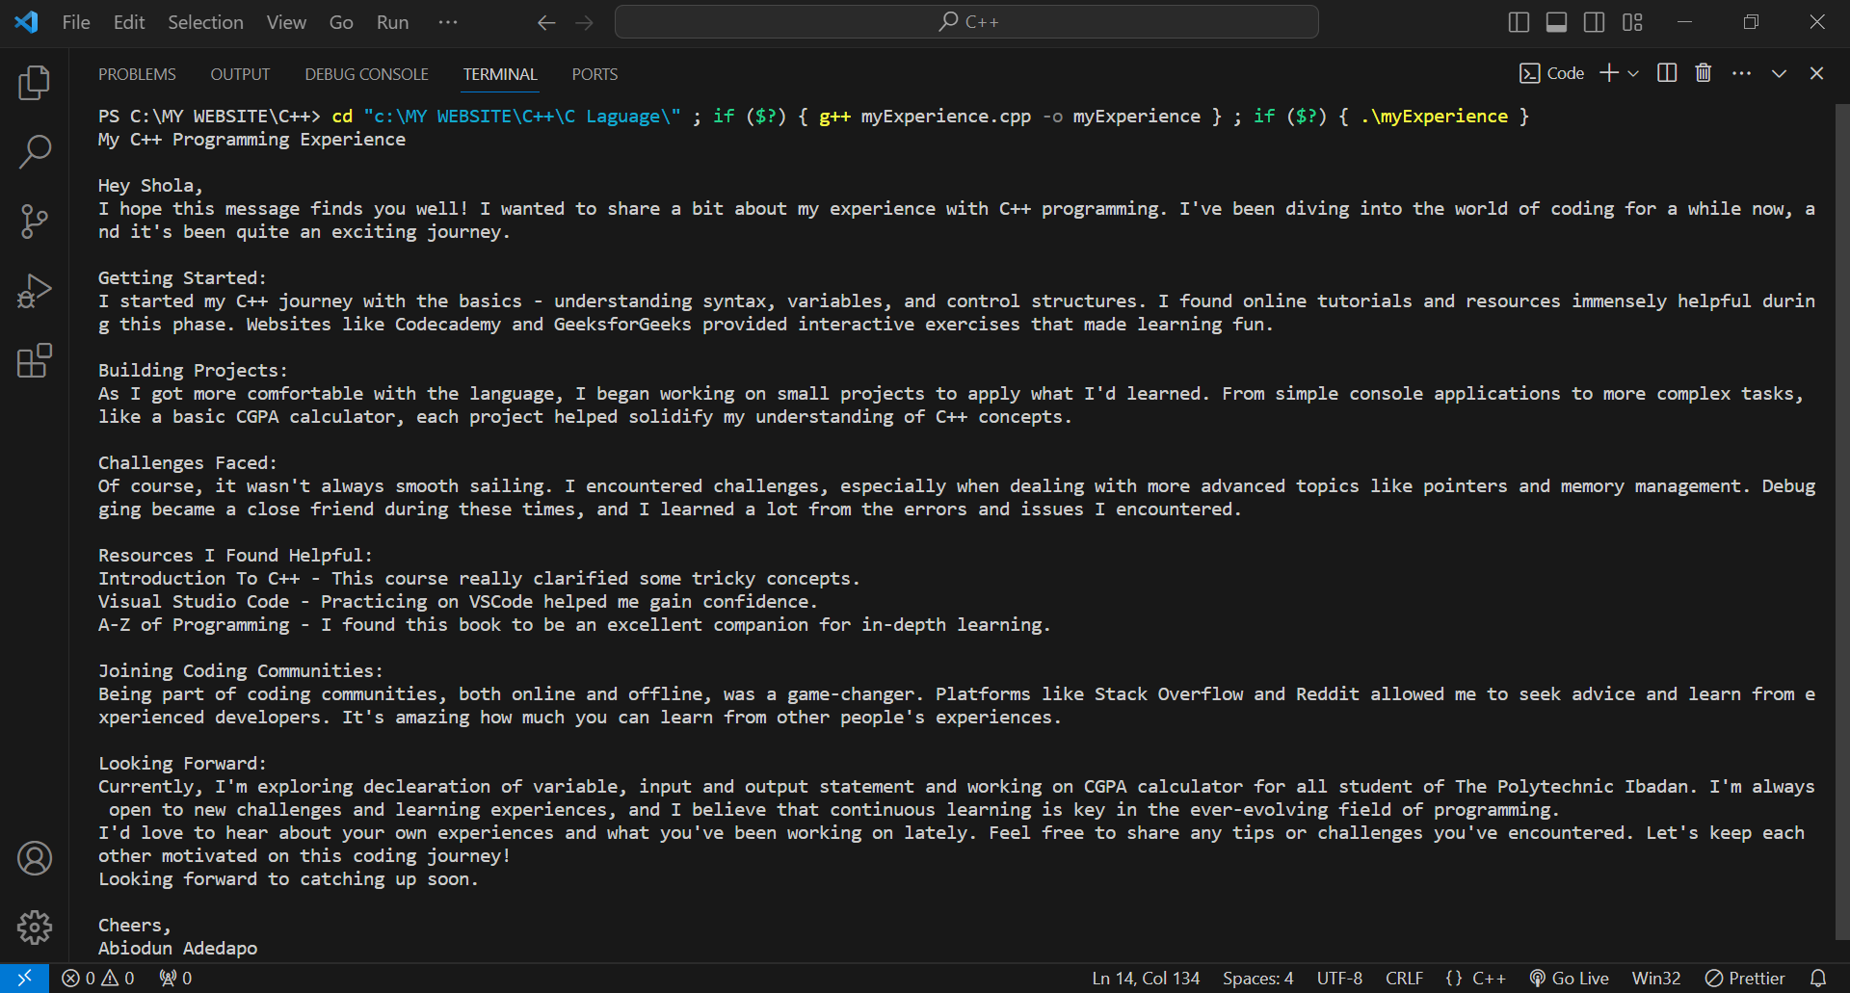

1. C++ program to calculate CGPA for 4 semesters: *Codes:*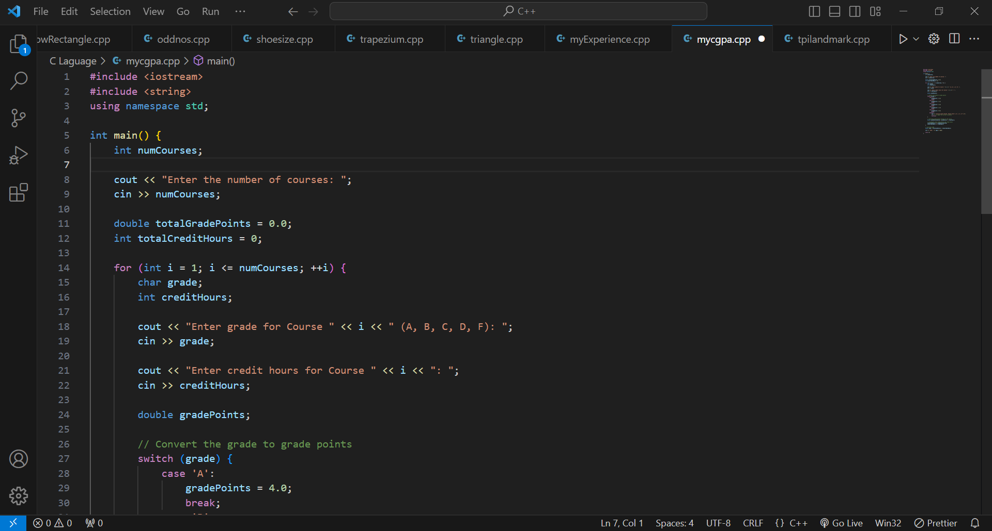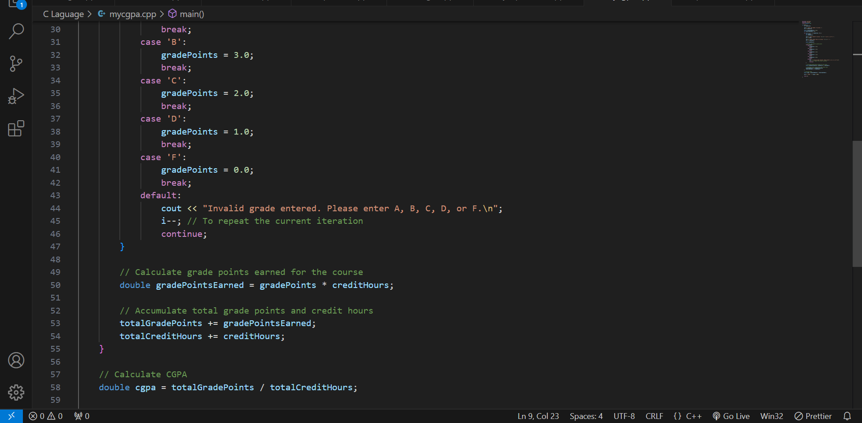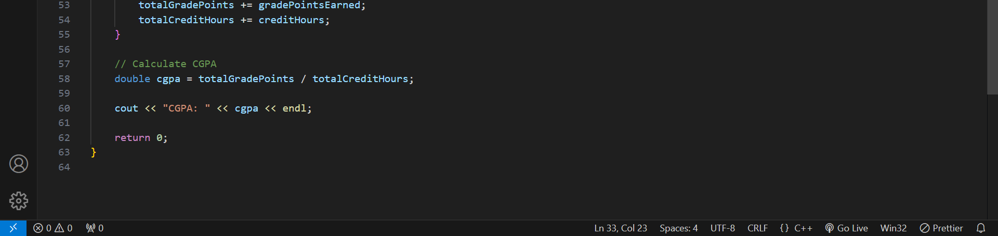

*Output:*

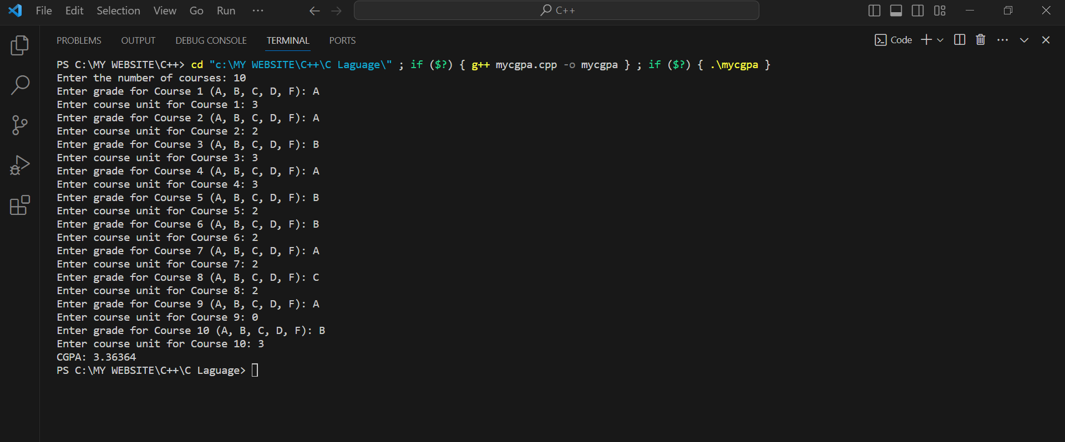

1. C++ program to calculate area of a lecture hall: *Code*

